Reflow controller

Reflow general description

From [Wikipedia](http://en.wikipedia.org/wiki/Reflow_soldering):

***“Reflow soldering****is a process in which a*[*solder paste*](http://en.wikipedia.org/wiki/Solder_paste)*(a sticky mixture of powdered*[*solder*](http://en.wikipedia.org/wiki/Solder)*and*[*flux*](http://en.wikipedia.org/wiki/Flux_(metallurgy))*) is used to temporarily attach one or several electrical components to their*[*contact pads*](http://en.wikipedia.org/wiki/Contact_pad)*, after which the entire assembly is subjected to controlled heat, which melts the solder, permanently connecting the joint. Heating may be accomplished by passing the assembly through a*[*reflow oven*](http://en.wikipedia.org/wiki/Reflow_oven)*or under an* [*infrared lamp*](http://en.wikipedia.org/wiki/Infrared_heater)*or by soldering individual joints with a hot air pencil.”*

The reflow process have several phases: Ramp to Soak, Soak, Ramp to peak and Cooling.

See: Figure 1 Reflow Profile Example

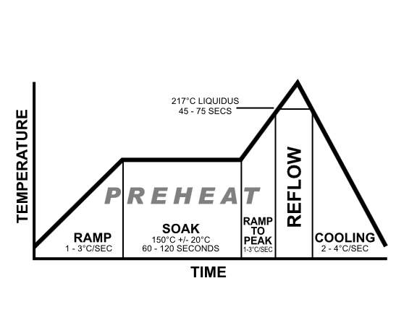

Figure 1 Reflow Profile Example

Each phase is defined by its start and end temperatures and by duration. The temperature in each phase is linear function of time.

The exact reflow phases’ parameters depend on the solder paste used and maybe other parameters (For example irregularities of heat inside the toaster oven)

We will reach the final parameters with experience.

Our project:

See: Figure 2 TAMI - Reflow Oven Diagram

D:\users\Zvika\Documents\eagle\Reflow Controller\TAMI _ Reflow Controller V5.tif

Figure TAMI - Reflow Oven Diagram

The PC provides GUI and control for the reflow process.

The PC also enables building, editing and storing of reflow profiles.

The Arduino board performs the real time reflow process. The reflow profile is preloaded into the Arduino memory. The Arduino controls the SSR which switches the current through the oven filament. The control is of ON/Off type with variable duty cycle (i.e. PWM).

The Arduino gets temperature readings from the K-type thermocouple via the MAX6675 (Temperature to digital converter).

The Arduino compares the actual temperature readings to the required temperature profile and adjust the current through the oven filament accordingly.

For the time being we use max power at ramp to soak and ramp to peak states, simple on/off control during soak state, some primitive P control (Proportional) towards the end of the ramp to soak state and power off with partial opening of the oven door during the cooling state.

(Full PID control will be developed at later stage.)

During the reflow process the Arduino is sending temperature readings, current state and state time to the PC for real time process display.